Guide to getting access to your Sociology Textbook electronically and other online resources.
First go to the website listed below and register as a student. (If you already have a Pearson account you will just need to log in)
http://www.pearsonmylabandmastering.com/northamerica/
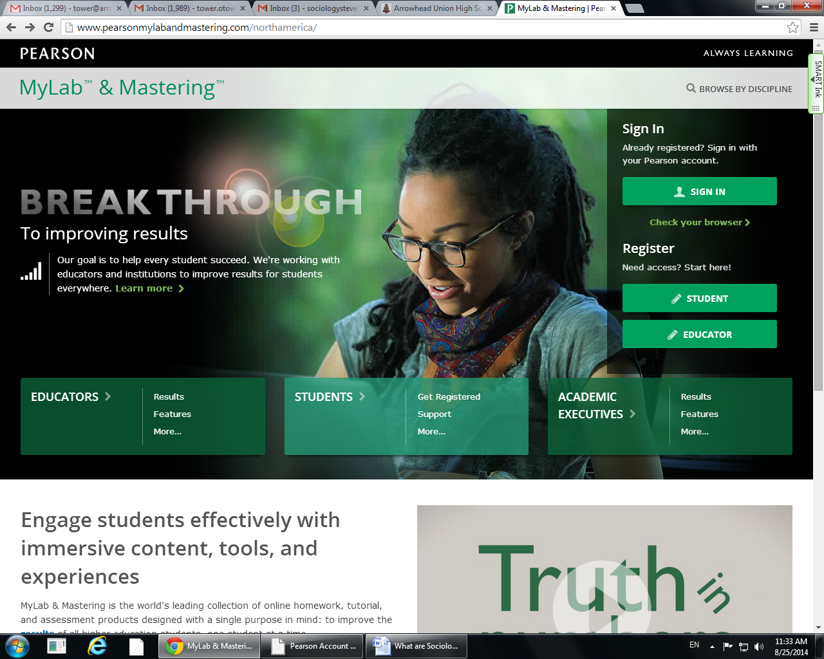
The next screen will ask you to make sure you have three items, 1- an email, 2 – a course ID and lastly – 3 an access code.
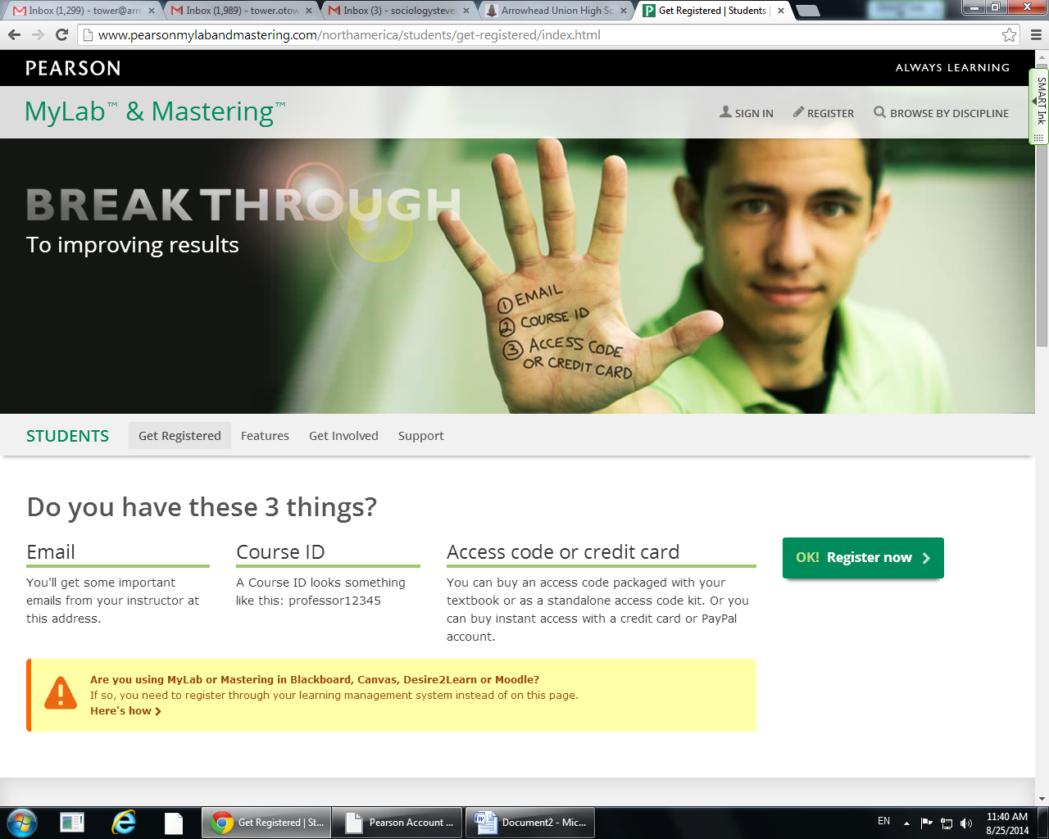
- This Is your school email
- Course ID: tower97473

1-SSNAST-CLINK-VEXIN-BOLET-SWASH-WIRES
2-SSNAST-AHEAD-VEXIN-BOLET-HAMZA-TAXES
3-SSNAST-NANDA-VEXIN-BOLET-INGOT-MACES
4-SSNAST-ATOLL-VEXIN-BOLET-GNASH-TOUSE

Enter in Course ID
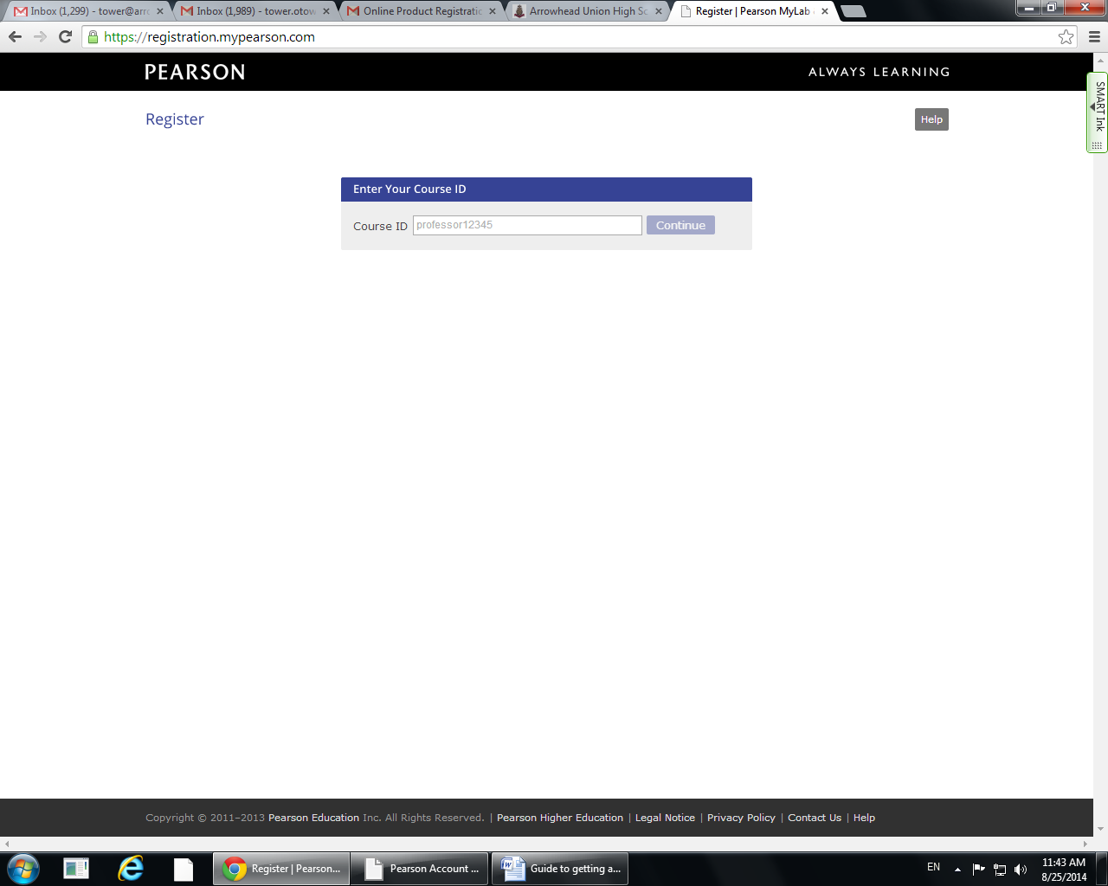

Next Screen will ask for your log in, at this point you should have gotten this via email.
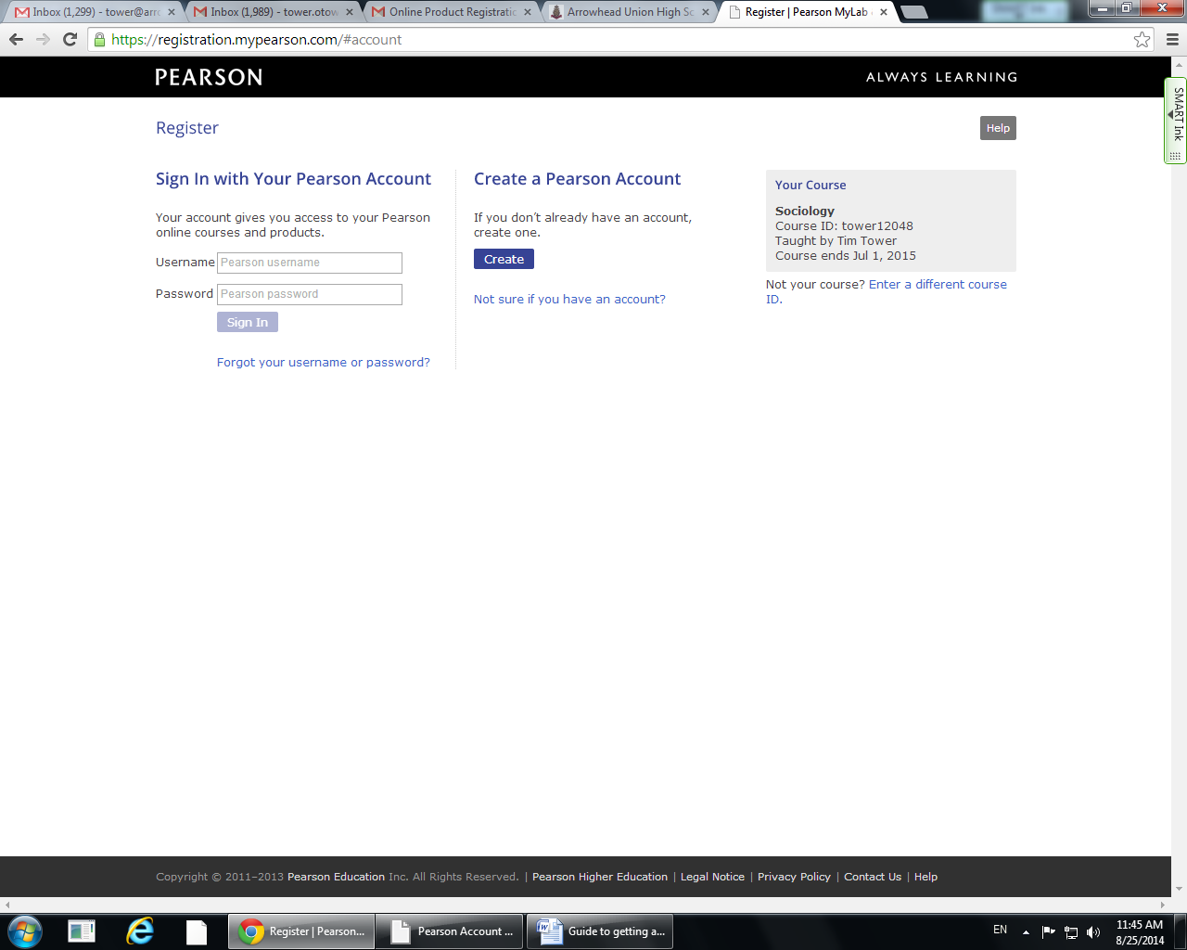

Now you will use the Sociology Portal to sign in.
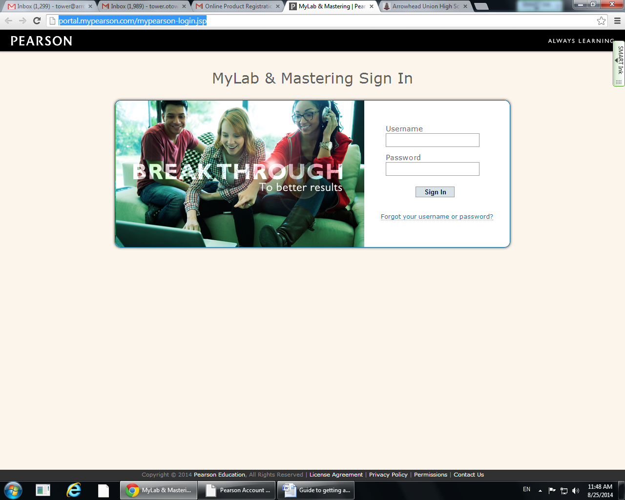
Once you get to this screen you have now accessed the online version of your textbook.
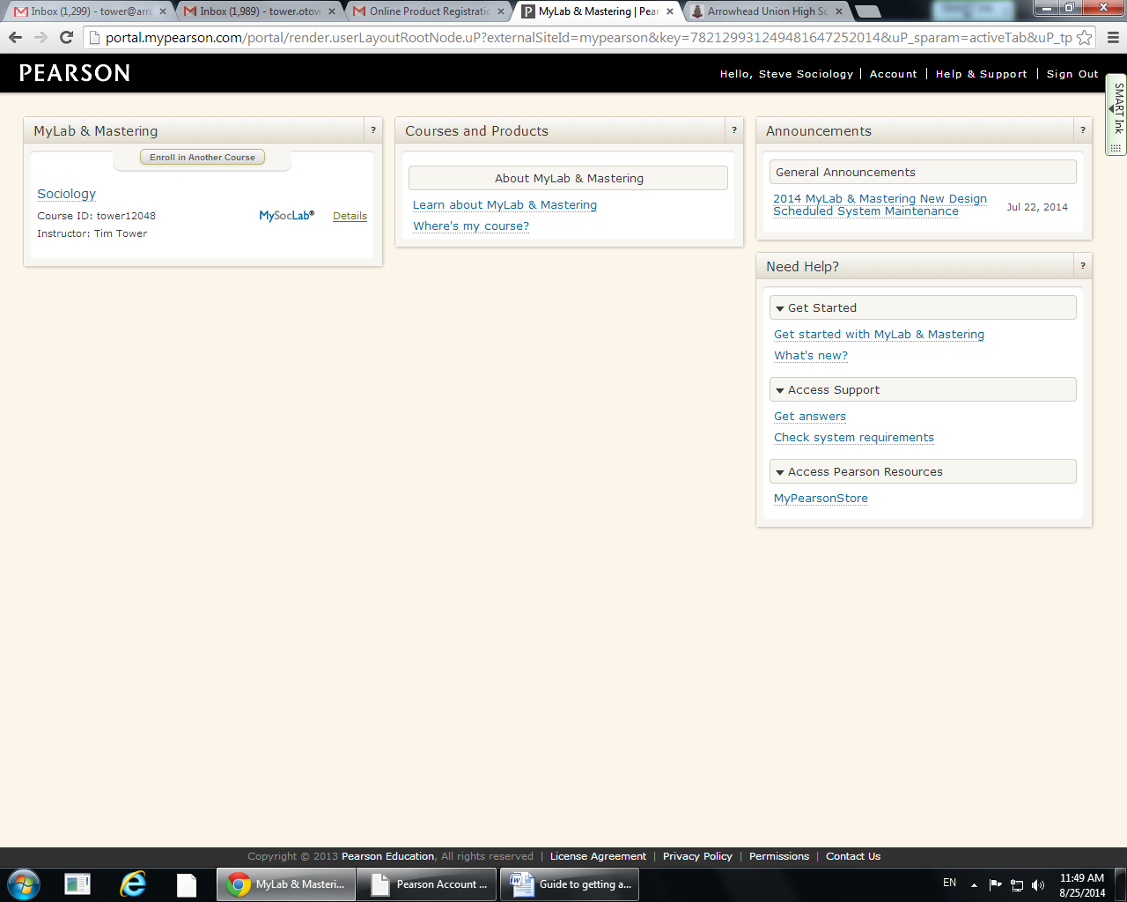
Now click on the term Sociology in the MYLAB & MASTERING section, this will gain you access to everything the online textbook has to offer. At this point we will not be using any of the grading online or writing portions but you have access to practice tests, quizzes, flashcards, videos, etc.
If you have questions please feel free to email me at tower@arrowheadschools.org

